Algorithms assignment- gavin skehan
(i) Show the resulting paragraph when the standard pre-processing steps are carried out, using a stemmer rather than a lemmatizer. Clearly state the steps taken and state what stop word list is used and what stemmer is used.
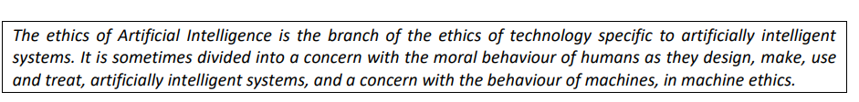
Stop word list using -stopwords1.txt and porter stemmer
The ethic of Artifici Intellig is the branch of the ethic of technolog specif to artifici intellig system It is sometim divid into a concern with the moral behaviour of human as thei design make us and treat artifici intellig system and a concern with the behaviour of machin in machin ethic
- Change uppercase letters to lowercase
- Remove any punctuation such as full stops and commas.
- Any words that end in ‘es’ remove the ‘s’
- Stem the important words eg intelligence turns to intellig

(ii) Using the pre-processed paragraph from part (i) show how the tf-idf (term frequency - inverse document frequency) weighting scheme is used to calculate a weight for the term ‘ethic’ given that there are 220 documents in the document collection and that the term occurs in 50 of them. You may assume that the word 'ethics' is stemmed to the term 'ethic'.
Calculating the inverse document frequency
- Web search index is based on term weights which are calculated after pre-processing steps have been performed
- Tf = the number of times the term is in the paragraph divided by the total terms in a paragraph. Tf = 3/52 = 0.05769
- Using the formula below input terms for t and N for the number of document,
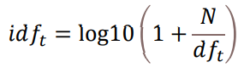
- The idf output should be a low value
- 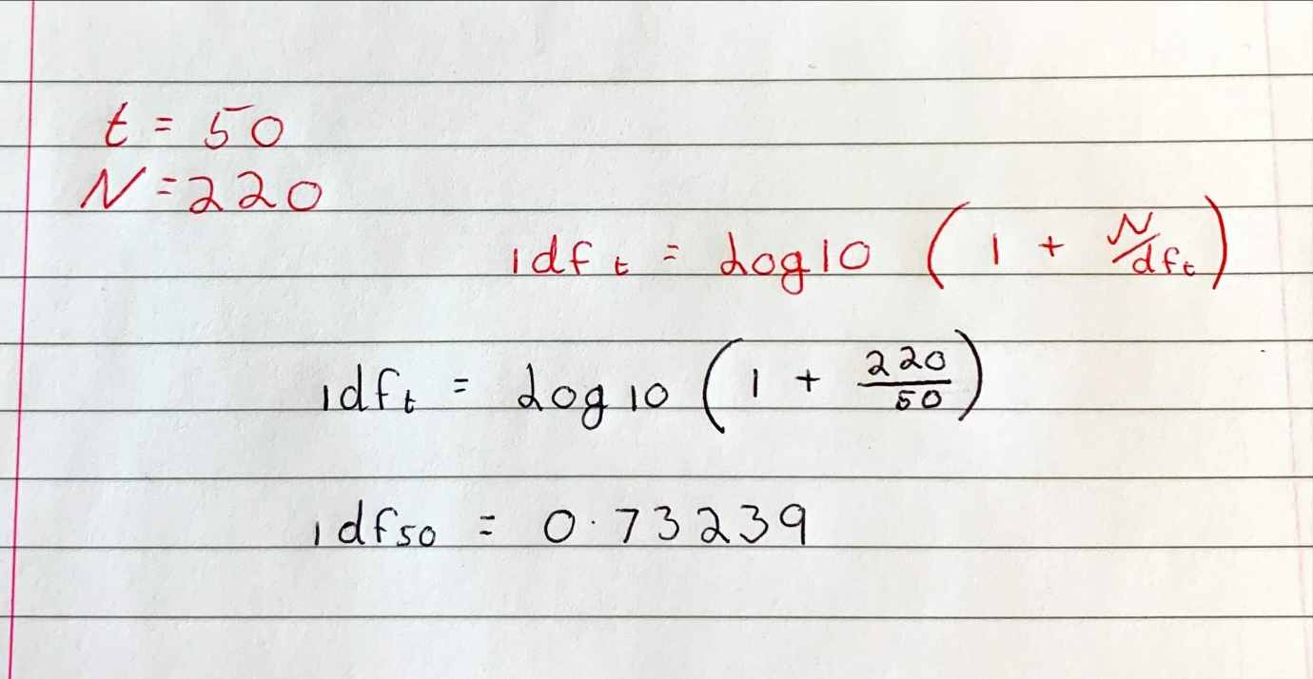
- For idf you must know the number of documents and the number of times the term appears in the documents
- Input the values into the formula using the calculator
To find the tf-idf multiply the two answers together
0.05769 * 0.73239 = 0..4225

2. Given the following two vectors representing some of the text content of two web pages:
< 0.30, 0.25, 0.1, 0.02, 0.00, 0.11 >
< 0.35, 0.00, 0.3, 0.11, 0.02, 0.20 >
Calculate the similarity between the two given vectors using the cosine similarity (Euclidean dot product) to an accuracy of at least three decimal places (i.e. 3 digits after the decimal point). Clearly show your workings - you may take a picture of hand notes and include in your document if legible
- First multiple the corresponding vectors
- Add the product of the vectors together
- Square and add line A then get the square root of that number
- Repeat step 3 for B then multiply the product of each
- Divide the product of step 2 (0.1592) by the product of step 4 (0.2153479)
- Record answer to 3 decimal places
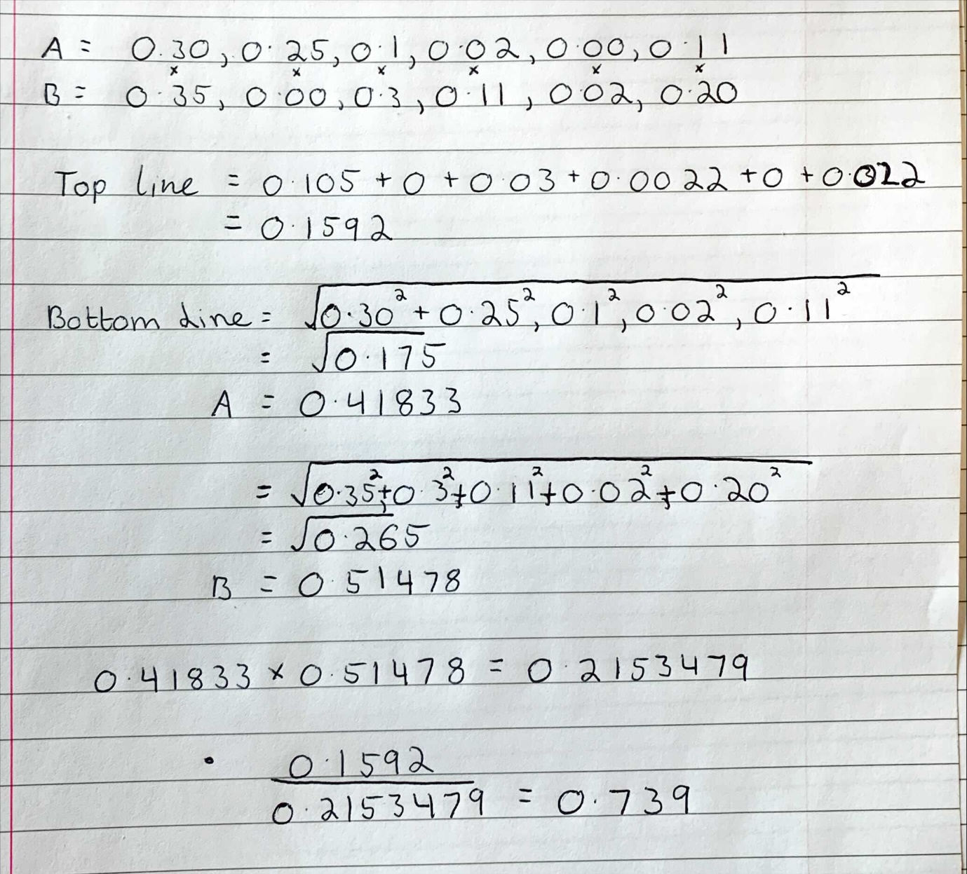

3. Given the following six web pages (A, B, C, D, E and F), and the hyperlinks between them:
(A, B), (A, C),
(B, A), (B, D), (B, F),
(C, A), (C, B), (C, E),
(D, E), (D, F),
(E, A), (E, B), (E, C), (E, F),
(F, B), (F, D)
- Write the PageRank formula which can be used to calculate the PageRank scores for each web page, including all necessary information

PR(A) = (1-d)/N + d * (PR(T1)/C(T1) + … + PR(Tn)/C(Tn))
- PR(T1) = the page rank score of the page
- C(T1) = the number of outputs of the page that links to A eg C links to A
- The original page rank for the pages are 1/6, 6 being the number of pages (N=6) and also we use 0.85 as D
- Note the page ranks carry over so when you calculate A, input PR(A) into PR(B) and so on.

- Calculate the page rank score of each of the web pages, showing the final scores of each page. Also include in your answer the number of iterations taken to find the scores.

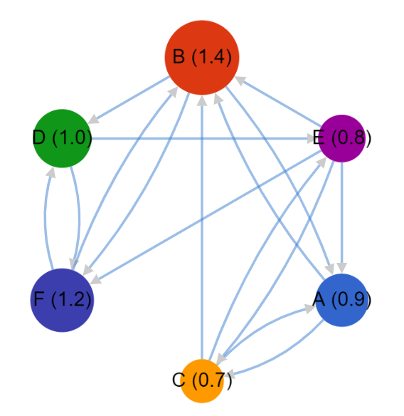
- Using code we let the computer do all the work!

#include <stdio.h>
void main() {

float cA = 2;
float cB = 3;
float cC = 3;
float cD = 2;
float cE = 4;
float cF = 2;

float prA = 1;
float prB = 1;
float prC = 1;
float prD = 1;
float prE = 1;
float prF = 1;

for (int i = 0; i < 10; i++) {

prA = 0.15 / 6 + 0.85 * ((prB / cB) + (prC / cC) + (prE / cE));
prB = 0.15 / 6 + 0.85 * ((prA / cA) + (prC / cC) + (prE / cE) + (prF / cF));
prC = 0.15 / 6 + 0.85 * ((prA / cA) + (prE / cE));
prD = 0.15 / 6 + 0.85 * ((prB / cB) + (prF / cF));
prE = 0.15 / 6 + 0.85 * ((prC / cC) + (prD / cD));
prF = 0.15 / 6 + 0.85 * ((prB / cB) + (prD / cD) + (prE / cE));

printf("-----------------\n");

printf("Page Rank A = %.3f\n", prA);
printf("Page Rank B = %.3f\n", prB);
printf("Page Rank C = %.3f\n", prC);
printf("Page Rank D = %.3f\n", prD);
printf("Page Rank E = %.3f\n", prE);
printf("Page Rank F = %.3f\n", prF);
}

}

We get the folloqing outputs for 10 ilterations:
1-4 iteration 5-8 iteration
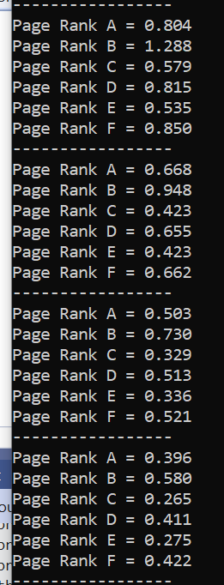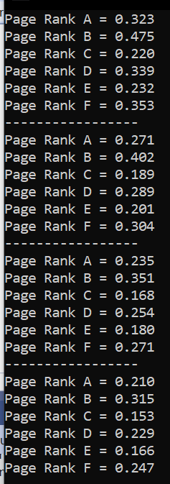

9-10 iteration 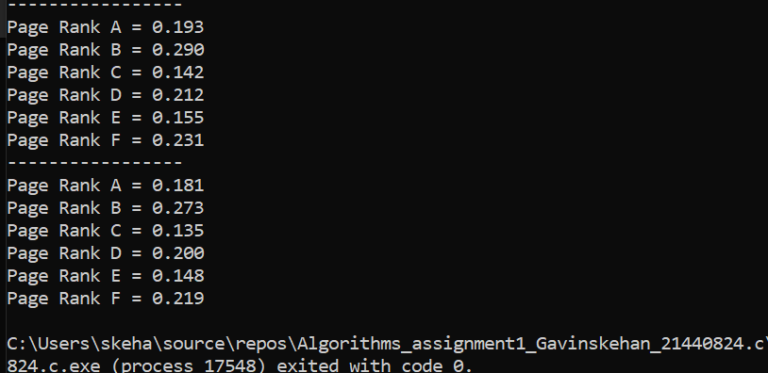
Plagiarism Declaration: “I am aware of what plagiarism is and include this here to confirm that this work is my own”

